User Requirement Document
(URD)
Ver 0.1
Created: 05/23/2012
Author: Tam Do
Updated: 05/23/2012

Version

No. | Date | Version | Description | By
01 | 05/23/12 | 1.0 | First Issues | Tam Do

Table of Contents
1. Introduction 4
1.1. Purpose of the document 4
1.2. Scope of the document 4
2. Use Case Diagram 5
3. Use case Description 6

- Introduction
  - Purpose of the document
- This document describes the user requirement for Smart Market System
  - Scope of the document
- Use Case Diagram

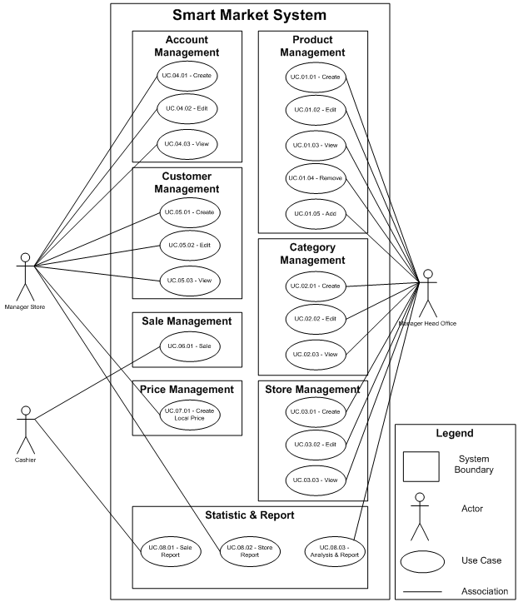
- Use case Description

